

Department | FED
Subject | DSA-2
Academic Year | Ⅰ-Ⅲ Semester(2025-26)
Faculty Name | Ms. Alluri Swathi
Student Name | N. Tejasri
Roll Number | 2520030132
Branch | CSE
Course Outcome | 1
Case Study Topic: SecureVote – Digital Voting & Election Analytics System using BST

Work Done Summary:
Implemented a Binary Search Tree (BST) in Java keyed by voterId / voteTimestamp. Inserted multiple voter records and vote entries into the BST. Implemented voter registration, secure ballot casting, vote counting, election analytics, fraud detection, and auditing operations. Deleted invalid or duplicate vote records and maintained proper BST structure. Implemented traversal methods for displaying election results in sorted order. Added methods for searching voters quickly and generating top election statistics. Compared BST performance with ArrayList – BST provides faster searching and organized data handling for election systems.

Implementation Details :
- Created BST Node class with fields: key, voterId, candidateName, left, right.
- insert( ) recursively inserts new voter/vote records into the BST.
- search( ) finds voter details and validates authentication.
- delete( ) removes duplicate/fraudulent vote records.
- inorderTraversal( ) displays votes and election results in sorted order.
- voteCount( ) calculates total votes received by each candidate.
- fraudDetection( ) checks duplicate voting attempts.
- Main method demonstrated voter registration, vote casting, searching, deletion, analytics, and result reporting.

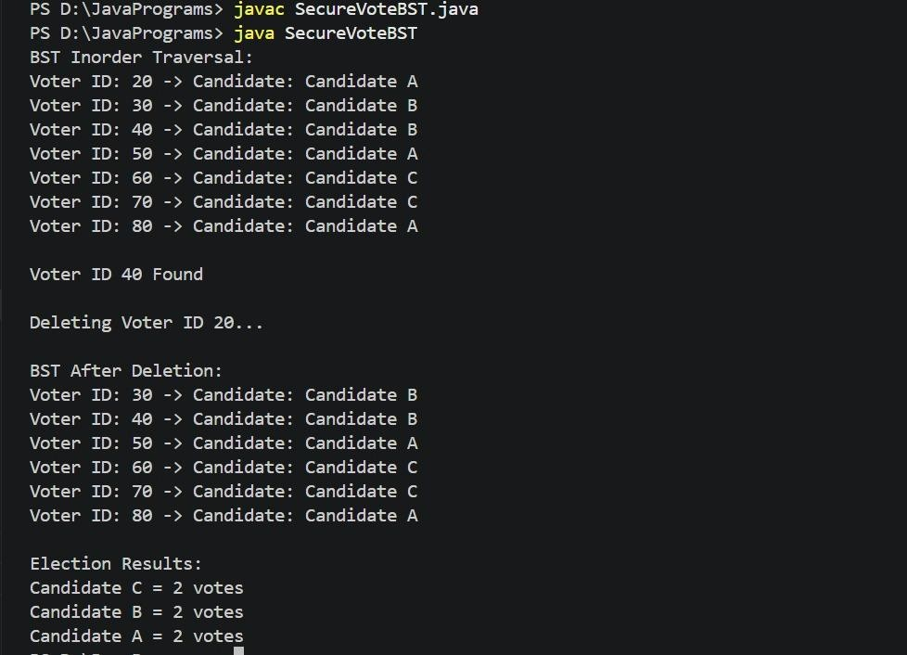
Result : Screenshots/Output

Time Complexity:
  - BST Insert/Delete/Search: O(log n) (average case)
  - Vote Counting Traversal: O(n)
  - Compared to ArrayList searching O(n), BST performs better for large-scale election data management.

GitHub Link : https://github.com/tejasri3123/Dsa-2
Student Signature | Faculty Signature

